Focus Group
Community Business Awareness Slot
Topic Presentation (5 minutes)

Topic B0303: Lean Six Sigma Core Principles
https://www.google.com/search?q=ted%20talk%20lean%20six%20sigma#fpstate=ive&vld=cid:0dff915d,vid:gHSp-1Ixolg
Presenter:
Steve Jobs
(3.21 minutes)
Topic Discussion (20 minutes)
Six Sigma is a defined and disciplined business methodology to increase customer satisfaction and profitability by streamlining operations, improving quality and eliminating defects in every organization-wide process.
- Customers form their own opinions on products and services when using and experiencing it.
Customers define quality (“The customer is always right”)
- Quality perceptions are created by credible experiences by clients.
- Norms and standards set an average acceptable industry standard for users.
- It starts with a willing culture and attitude at the production line.
- Quality is not just the product or the service
To measure is to know – also efficiency of utilisation
- Caring enough to walk the extra mile. (differentiator)
- Selecting the right product or service most suitable for your need.
- Build in processes to get feedback from clients to adjust performance.
- Why is it done this way?
Trust your employees to participate in continuous improvement
- Opportunity to question why, how and what we do?
- Trust your employees – Optimistic humanism.
- Continuous Improvement.

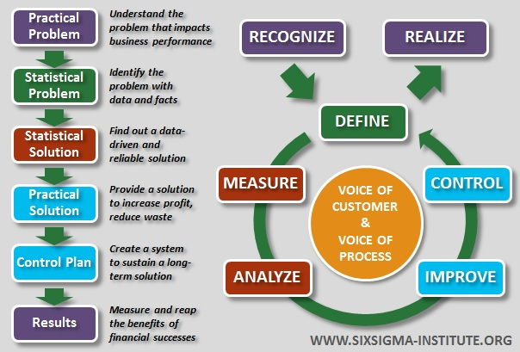

ISO 9001 (2015) The quality management principles are:
- customer focus;
- leadership;
- engagement of people;
- process approach;
- improvement;
- evidence-based decision making;
- relationship management.

Questions:
- How do you know what product or service quality is good enough to start with?
- How do you get feedback from your clients?
- How do you develop a quality culture in your business?

