Embracing authentic demand: The core of innovation leadership
BY MATT CHANOFF, MERRICK FURST, DANIEL SABBAH AND MARK WEGMAN
PUBLISHED: NOVEMBER 8, 2023

https://corp.smartbrief.com/original/2023/11/embracing-authentic-demand-the-core-of-innovation-leadership

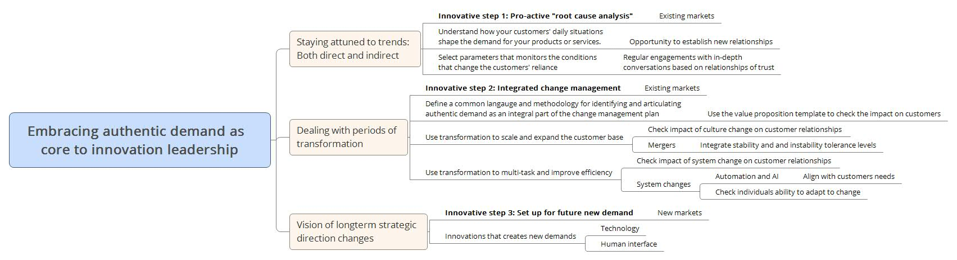

https://www.ted.com/talks/joseph_pine_what_consumers_want?autoplay=true&muted=true

